

Assignment 3

- College: College of Computing
- Major: Computer Science
- Supervisor: Man Hon Michael CHEUNG
- Student Name: CHEN Xian
- Student Number: 5XXXX

Chapter 6
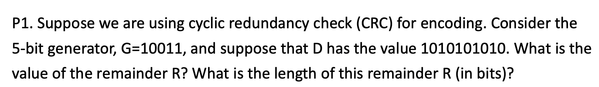 ANS:
The value of the remainder R is 4, and the length is 4 bits.
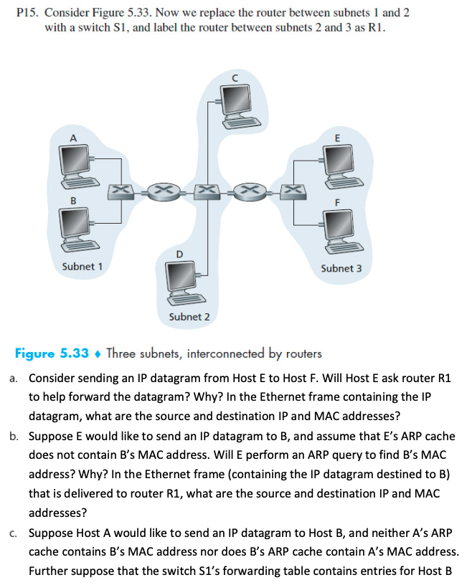
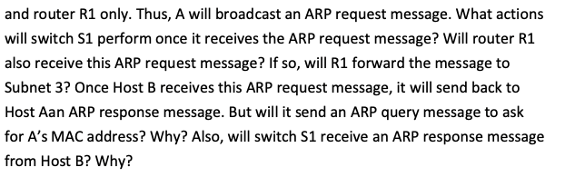
ANS:
- No. Because Host E and Host F are both in the same subnet. According to IP routing logic, E will recognize that F’s IP address is in the same network segment as its own, so it sends the packet directly at the link layer without using the default gateway.
Source IP: E’s IP address; Destination IP: F’s IP address; Source MAC: E’s MAC address; Destination MAC: F’s MAC address;
- No. Because Host B is in Subnet 1 while E is in Subnet 3, they are in different subnets. E must send the packet to its default gateway (the Subnet 3 interface of router R1). Therefore, E will only perform an ARP query for R1’s MAC address.
Source IP: E’s IP address; Destination IP: B’s IP address; Source MAC: E’s MAC address; Destination MAC: R1’s MAC address;
- S1 will flood the frame, and at the same time, S1 will learn A’s MAC address and record it in its forwarding table.
R1 will receive the ARP request, because it is connected to S1. However, R1 will not forward this message to Subnet 3, because routers isolate broadcast domains, and an ARP request is a link-layer broadcast that cannot pass through a router.
No. Because A’s ARP request already contains A’s IP and MAC address. When Host B receives the request, it automatically adds A’s mapping entry to its own ARP cache, so it does not need to perform a reverse query
Yes. The ARP reply is a unicast frame sent from B to A. The physical path is Host B →Switch S1 → Host A. Therefore, S1 will inevitably receive and forward the frame.
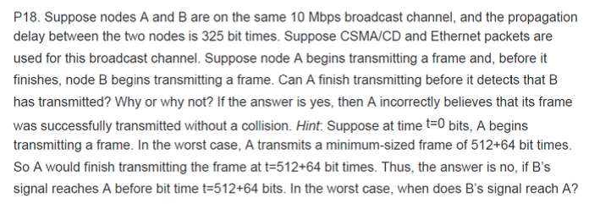
ANS:
Yes.
To detect a collision while transmitting, a node must still be transmitting the frame when the collision signal from the other node reaches it. In the worst-case scenario, the time it takes for a collision signal to propagate back to sender A is twice the propagation delay
「L$≥$($2×dprop)$」.
BUT:
Time for A to finish transmitting the frame:
Ttrans = L = 576 bit times.
Time for the collision signal to return to A (Worst-case Round Trip Time):
RTT = 2$×$dprop = 2$×$325 = 650 bit times.
RTT$>$Ttrans
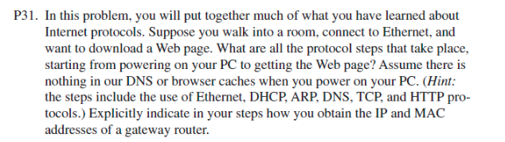
ANS:
- DHCP (obtaining its own IP and gateway information)
When the PC is powered on, it has no IP address. It runs the DHCP protocol over UDP. The PC broadcasts a DHCP Discover frame. The DHCP server replies with a DHCP Offer, which includes the PC’s IP address, subnet mask, DNS server IP, and the IP address of the default gateway router.
- ARP (obtaining the gateway’s MAC address):
The PC needs to send a query to the DNS server, so the packet must be sent to the default gateway. The PC checks its ARP cache and finds no MAC address corresponding to the gateway’s IP. The PC uses the ARP protocol to broadcast: “Who has Gateway IP? “The gateway router replies with an ARP response, providing its MAC address.
- DNS (resolving the domain name):
Now that the PC knows the gateway's MAC address, it can send a DNS query. The query asks: “What is the IP address of www.xxxx.com?” Packet: Src IP = PC, Dst IP = DNS server. Frame header: Dst MAC = gateway’s MAC. The DNS server replies with the IP address of the target website.
- TCP (establishing a connection):
After obtaining the web server’s IP address, the PC begins establishing a connection using the TCP protocol. Three-way handshake: send SYN → receive SYN+ACK → send ACK.
- HTTP (requesting the webpage):
After the TCP connection is established, the PC sends an HTTP GET request. The server returns an HTTP response. The browser renders the webpage.

